This homework assignment is based on Chapter 4 Loops.

**There are 3 projects, each worth 33.3%**

Complete the following programs using any looping construct.

**Project #1**

**#1 Print screen the code with the output below here.**

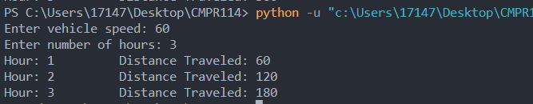

Code:

speed = int(input("Enter vehicle speed: "))

hours = int(input("Enter number of hours: "))

for i in range(1, hours+1):

calc_distance = i * speed

print(f"Hour: {i}\t\tDistance Traveled: {calc_distance}")

**Project #2**

**#2 Print screen the code with the output below here.**

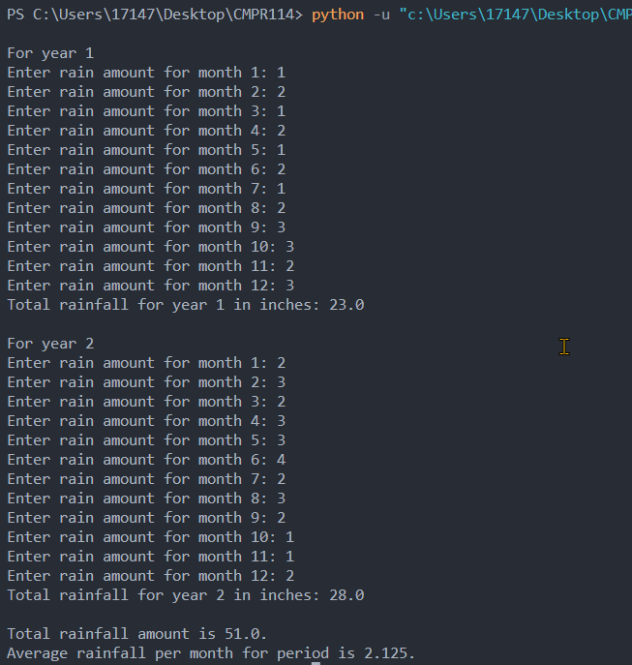

Code:

years = int(input("Enter number of years: "))

totalrain_year = 0

for year in range(1,years+1):

totalrain = 0

print(f"\nFor year {year}")

for i in range(1,13):

rain = float(input(f"Enter rain amount for month {i}: "))

totalrain = totalrain + rain

print(f"Total rainfall for year {year} in inches: {totalrain}")

totalrain_year = totalrain_year + totalrain

avgrain = totalrain_year / (years*12)

print(f"\nTotal rainfall amount is {totalrain_year}.")

print(f"Average rainfall per month for period is {avgrain}.")

**Project #3**

**#3 Print screen the code with the output below here.**

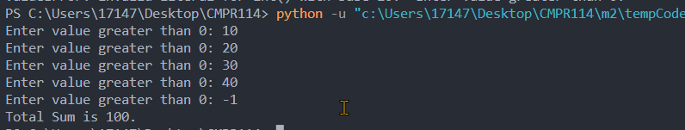

Code:

num = 1

totalsum = 0

while num > 0:

num = int(input("Enter value greater than 0: "))

if num > 0:

totalsum = totalsum + num

print(f"Total Sum is {totalsum}.")

**Submit this document to module 2 homework.**